*Use the information in Chapter 8 (p.142-160) to complete the reading guide.*

**Concept 8.1 An organism’s metabolism transforms matter and energy**

1. Explain what a metabolic pathway means and differentiate between pathways that are catabolic vs. anabolic.
2. Complete the following table to define the various types of energy.

|  |  |
| --- | --- |
| **Type of Energy** | **Description** |
| Kinetic |  |
| Heat/Thermal |  |
| Potential |  |
| Chemical |  |

1. State the first and second laws of thermodynamics below and give an example of each.

|  |  |  |
| --- | --- | --- |
|  | Description | Example |
| First Law: |  |  |
| Second Law: |  |  |

1. What is the difference between a spontaneous and non-spontaneous reaction?
2. Explain why living organisms (who regularly synthesize organized molecules) do not violate the second law of thermodynamics.

**Concept 8.2 The free-energy change of a reaction tells us whether or not the reaction occurs spontaneously**

*This part of the chapter is a bit confusing, so before you read, watch Bozeman’s* [*Gibb’s Free Energy*](http://www.bozemanscience.com/gibbs-free-energy) *and answer the following questions.*

1. What is “free energy”?
2. Define the following variables in the Gibb’s free energy equation: ΔG = ΔH – TΔS

|  |  |
| --- | --- |
| Symbol | What does it represent? |
| ΔG: |  |
| ΔH: |  |
| T: |  |
| ΔS: |  |

1. What does ΔG look like in a spontaneous vs. non-spontaneous reaction?
2. List three ways that you could decrease the ΔG value and three ways to increase the ΔG value.

ΔG = ΔH – TΔS

1. What are the classic exergonic (spontaneous) and endergonic (non-spontaneous) reactions in biology? Draw, label, and summarize the energy diagram for each of these reactions.
2. Why is equilibrium BAD for cells?

**Concept 8.3 ATP powers cellular work by coupling exergonic reactions to endergonic reactions**

*Before reading the next section, you may want to check out Bozeman’s podcast on*[*ATP*](http://www.bozemanscience.com/atp-adenosine-triphosphate)*.*

1. List and describe three biological functions that require ATP to conduct cellular work.
2. 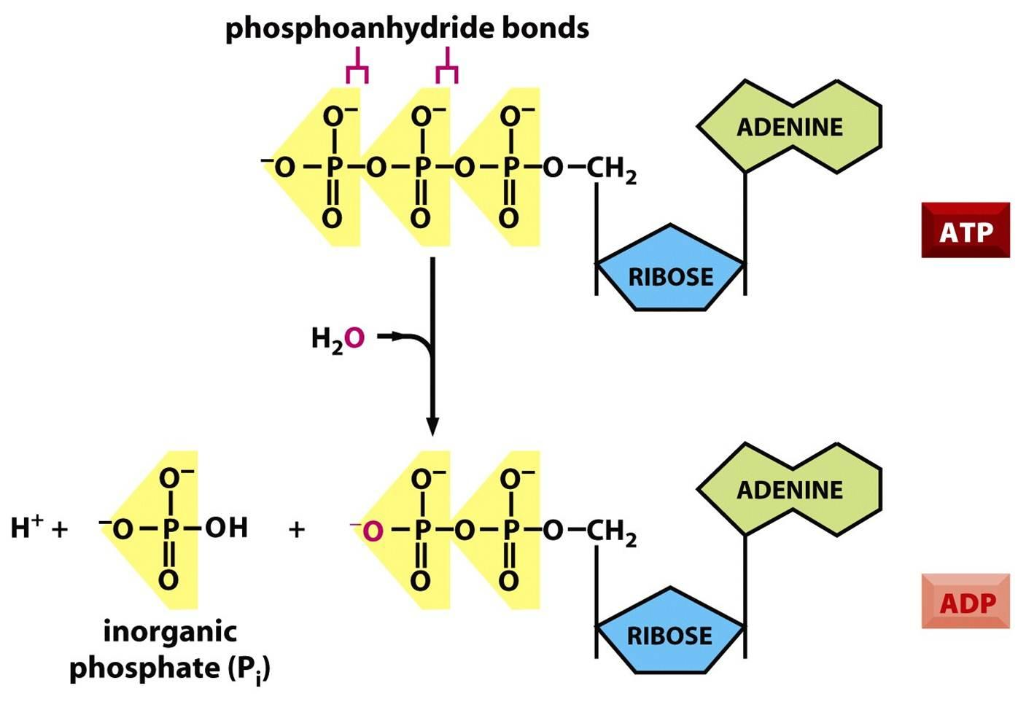Use the diagram to the right to describe how energy is released from ATP.
3. Compare the release of energy from ATP in a test tube to how a cell puts the energy stored in ATP to work. Be sure to explain the role of a phosphorylated intermediate.

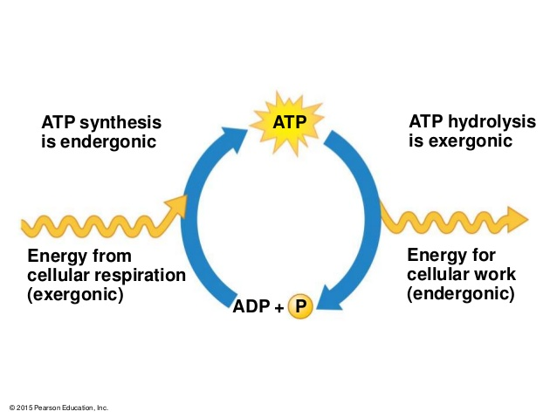

1. Use the diagram to the right to explain why ATP is a renewable resource.

**Concept 8.4 Enzymes speed up metabolic reactions by lowering energy barriers**

*Before reading the next section, you may want to check out Bozeman’s podcast on*[*Enzymes*](https://paul-andersen.squarespace.com/048-enyzmes)*.*

1. Explain how enzymes speed up chemical reactions. Draw a diagram to help explain (Figure 8.12 & 8.13 are useful!)
2. Create a concept map below that illustrates the relationship between the following terms. Draw diagrams if it helps to illustrate what is happening.

|  |  |  |
| --- | --- | --- |
| substrate | enzyme | active site |
| induced fit | enzyme-substrate complex | shape-change |

1. Describe the four ways enzymes lower the activation energy of a reaction.

|  |  |
| --- | --- |
| **What Enzyme Does** | **Description** |
| Template for substrate |  |
| Stretching substrate |  |
| Altering microenvironment |  |
| Direct participation |  |

1. Explain what optimal temperature and pH mean in terms of enzyme activity. Give two examples that help explain this idea.
2. Compare and contrast a cofactor with a coenzyme.
3. Compare and contrast competitive and non-competitive (allosteric) inhibition. Draw a diagram. *\*You may need to read ahead into Concept 8.5 (p.158) for allosteric regulation.*

**Concept 8.5 Regulation of enzyme activity helps control metabolism**

1. Is allosteric regulation always inhibitory? Explain.
2. 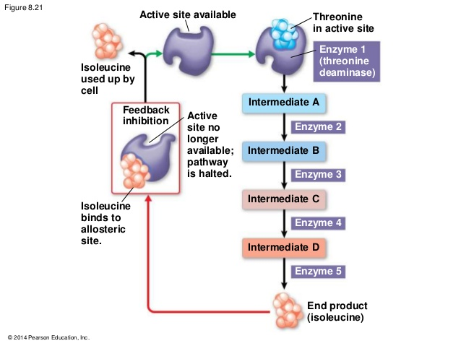Use the diagram to the right to discuss how a feedback loop can be used to inhibit metabolism.